Maven Configuration

### Install Maven:

Download the bin.zip file from <https://maven.apache.org/download.cgi>

Extract the downloaded file to C:\Program Files\Apache\Maven

Copy path to maven’s bin directory

E.g., C:\Program Files\Apache\Maven\apache-maven-3.9.9\bin

Then use the copied path to add to environment variables:

System Variables -> Path -> Paste copied path

System Variables -> MAVEN_HOME -> Paste copied path

Restart System.

### Creating a new Java Project using Maven: Shortcut: Ctrl + Shift + P

Select maven-quickstart-archetype and then version 1.4

Then give the groupID in all smalls. I have given ‘sptm25group04' to symbolize ‘Sask Polytech Tech Mgmt Group 04’

And ArtifactID is the project name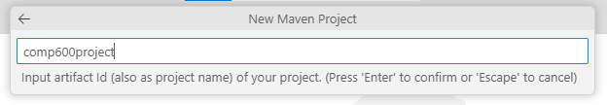

Then it will ask for destination folder to creating the project

After that It’ll start creating the project.

When it asks for SNAPSHOT, start clicking Enter key till it starts building the project. Wait till message shows as BUILD SUCCESS.

### Adding Dependencies:

Add the following dependencies in the pom.xml file

<!-- MySQL JDBC Driver -->

<dependency>

<groupId>mysql</groupId>

<artifactId>mysql-connector-java</artifactId>

<version>8.0.26</version> <!-- Latest version -->

</dependency>

<dependency>

<groupId>org.openjfx</groupId>

<artifactId>javafx-controls</artifactId>

<version>17.0.2</version> <!-- Use the latest version -->

</dependency>

### Install XML extension from Redhat

### Updating dependencies

After updating the dependencies in the pom.xml file, run *mvn clean install* in the terminal. This will clean the build and install dependencies.

